A Study on the Space Form and Sculpt of 3D Animation Background Modeling
- Focused on The Gestalt Principle of Organization -

Lingfeng Gu¹, Hyungjin Jeon², Hongsik Pak^{3*}

Department of Visual Contents, Graduate School, Dongseo University^{1,2}
Department of Digital Contents, Dongseo University^{3*}
Jurye Ro 47, Sasang Gu
Busan , South Korea
gulingfeng930903@gmail.com¹, h01086090095@gmail.com², hspak@dongseo.ac.kr^{3*}

Abstract

Modeling is an important constitution of 3D animation. Character modeling has been studied extensively in 3D animation. But the importance of background modeling for 3D animation has been overlooked. This paper attempts to improve the visual effects of 3D animation by controlling the arrangement of background modeling from the perspective of visual and conscious perception, grasp the spatiality of background modeling, and achieve the research purpose of form systematization. To this end, this paper presupposes a standard, that is, Through background modeling’s regular, symmetrical, single arrangements in the space, making people form the systematic visualization. Then demonstrate the applicability of this standard in two steps. First, we examine the Gestalt principle of organization, reveal the association with this standard and provide theoretical support for the standard. Second, set the animation company Disney and other 3D animation works as an example, analyze the use of this standard. Gestalt principle of organization is to achieve the means of form systematization. Applying standards can rationally arrange the background modeling and give people a comfortable visual experience to improve the performance of 3D animation screen force.

Keywords-3D animation, 3D background modeling, Gestalt principle of organization, spatiality, form systematization

I. Introduction

- Research Background and Objectives

I had ever published the paper <A study on the formal systematization within the 3D modeling designs> on Journal of Multimedia Information System(JMIS) in September 2017. Through the methods of literature investigation and sample analysis, on the theoretical foundation of Gestalt principle of organization, I drew the conclusion that the simplified, safe and symmetrical character modeling in 3D animation is more in line with human visual perception is required. However, the objectivity of the conclusion of this thesis remains to be discussed due to the lack of questionnaires. And the scope of this paper is limited to the animation of 3D character modeling. There is no study on the background modeling of 3D animations; J. Shin proposed the Gestalt principle of organization in the paper "A study on media- applied to the visual perception theory of Gestalt" published in July 2012, assuming the hypothesis of ability to communicate with the audience and analyzing as a questionnaire. lee, H. Kim published the paper "A study on Expression of Graphic with Gestalt theory", published in January 2011.Gestalt theory by some means in dynamic images, in a subtle and symbolic manner. In the digital environment explore applications. Based on time and space, we can analyze the dynamic images in a certain way and analyze them with examples of connected advertisements, music videos and performances, so as to draw conclusions. These papers are all based on the principle of Gestalt principle-organization, and this article should also be based on the principles of Gestalt principle-organization, form systematization research from the perspective of visual and conscious perception. Moreover, previous studies show that the research content that is related to Gestalt principle of organization and 3D Background modeling is currently vacant. So in this paper, based on the Gestalt principle of organization, it is necessary to study the Form systematization datum of 3D background modeling.
The existing literature lacks the content of visual perception associated with the arrangement of 3D background modeling. Background modeling's different arrangements in space would affect people's visual perception of 3D animation. The arrangement of background modeling should be related to the Gestalt principle of organization with visual perception as the main research object, and background modeling should be arranged rationally. Grasp the spatiality of background modeling, form systematization is the research goal of this paper. To this end, this paper proposes in advance a standard for form systematization. Then through the theoretical study of the Gestalt principle of organization, analyses the application situation of the standard under the existing 3D animation, two steps are used to demonstrate its applicability.

- research methods

This paper attempts to improve the visual effects of 3D animation by controlling the arrangement of background modeling from the perspective of visual and conscious perception, grasp the spatiality of background modeling, and achieve the research purpose of form systematization. The specific research methods are as follows: First, we point out that the existing research lacks a standard that can rationalize background modeling and improves the visual effects of 3D animation. Then, a form systematization standard is presupposed, and the details of the standard will be mentioned below. Second, we examine the relevance of the four principles in the Gestalt principle of organization to the hypothetical datum, and provide theoretical support for the standard. Thirdly, we analyze the background Modeling's hypothetical bench marking using the 3D animations <WALL.E> and <Despicable me> won by the animation companies Disney, Pixar and Universal Studios.

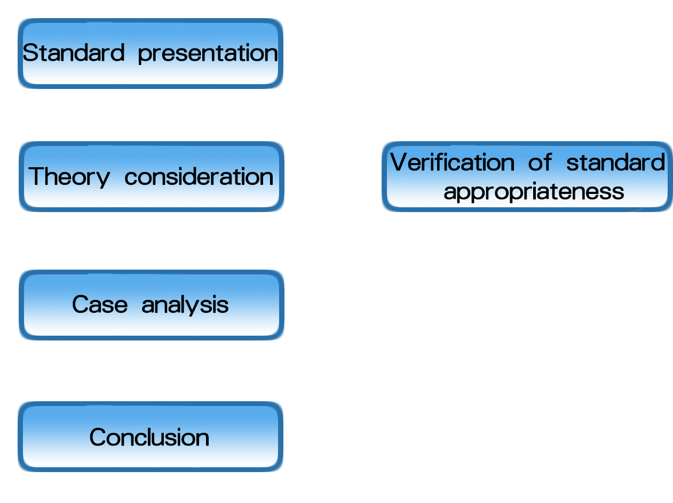

Fig 1 Analysis method

II. Hypothetical baseline of form systematization

Through the first research, we find that most of the research on 3D animation focuses on the character modeling, while the research on background modeling is still not enough. However, background modeling is also an important part of 3D animation. Background modeling provides a virtual space for 3D animation. Different arrangement of the background modeling will form a different space to affect the visual effects of 3D animation, thus affecting people's visual perception. In other words, background modeling is a way to control the visual effects of 3D animations. So this article focuses on the study of this arrangement. People perceiving the virtual space is not passive acceptance, but a proactive psychological process. About the meaning of the three-dimensional is the relationship between human and the world, formed under the communication and the formation of space on two axes [1]. Therefore, we should study from the perspective of visual perception as the main research object of Gestalt principle of organization. However, how to arrange the background modeling to make people's visual perception form a comfortable visual experience, thereby improve the visual effects of 3D animation, there is a unified standard in the existing research. Therefore, in order to solve this problem, this paper proposes in advance a hypothetical standard: form systematization can be achieved by systematically visualizing background modeling by arranging background modeling in a regular, symmetrical, and uniform manner in space.

III. Gestalt principle of organization in Psychology

Our brains are the organs that receive information, but it is a difficult task for the brain to receive and store all the information the eyes see intact [2]. Therefore, our brains need to organize, simplify and unify into a coordinated whole in some ways to make them easier to recognize and understand. As a result, Gestalt psychologists have proposed several organizational principles that illustrate how the brains organize and understand a range of elements.

TABLE I
GESTALT GROUPING PRINCIPLE

 | Grouping principles and illustrations | Feature
1 | Law of Proximity  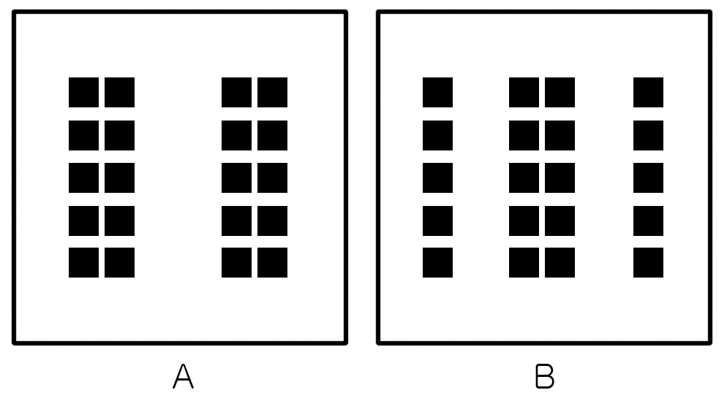 | elements close to each other in space are more likely to be seen as a group than those that are far apart.
2 | Law of Similarity  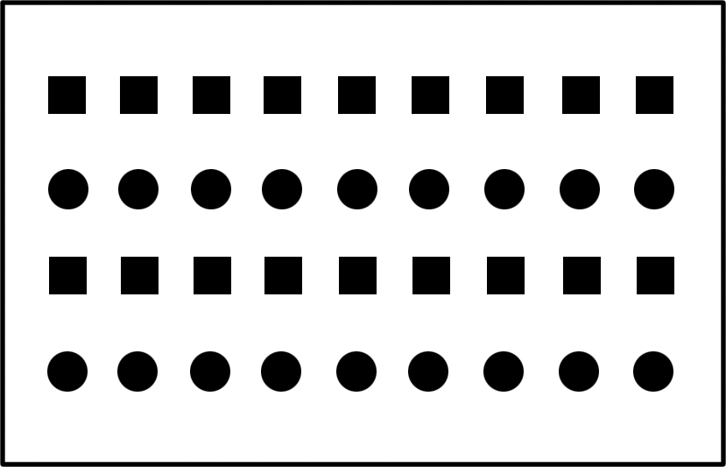 | people's visual perception is easy to organize similar parts into the whole.  Similar in shape, Similar in size, Similar in color, Similar in material.
3 | Law of continuity  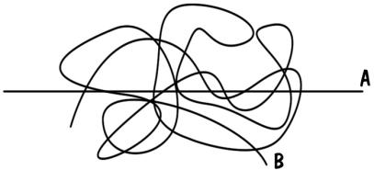 | When a certain form or organization has directionality and continuity, it is a characteristic common to the form. Soft continuity runs naturally in one direction, and objects are highly likely to see the same belonging..
4 | Law of Closure   | people's vision and perception have incoherent, notched graphics that make it as psychologically closed as possible. It makes it a complete continuous graph.

From Table 1, visual and conscious perception through the principle of proximity, according to the different distances between elements, the elements of the law of classification; by the principle of similarity, according to the same size, the same shape, the same color, the same material elements of the law Class; according to the principle of continuity, according to the directional strength of the elements arranged between the elements of the arrangement; by closed principle, notched, unsafe graphics perception as possible into a complete, single form. Through the relationship between organizational principles and the references mentioned in this article, organizational principles are the means to achieve a regular, symmetrical and single Form systematization.

V. Application of Organizational Principle in 3D Animation

In the previous chapter, we investigated the relationship between organizational principles and form systematization, and provided theoretical support for the standard. In order to continue arguing the appropriateness of this standard, this article examines the use of organizational principles in existing 3D animation works. Two examples were chosen for this article, one for <WALL.E> and the other for <Despicable me>. The reasons for choosing these two are as follows: The first and the second are both world famous animation companies Pixar, Disney, Universal Film company produced works, and the former won the 81st best animation lengthy award, and the 66th golden globe best animated short film award; The latter was nominated for the 86th Academy Award for Best Animation and nominated for the 71th Annual Golden Globe Award for Best Short Film. So has a high degree of recognition. Second, the instance of background modeling chosen makes sense for the animation itself. The <WALL.E> is selected at the beginning of the video, and then background modeling is the atmosphere for the film paving the way. Background modeling used in <Despicable me> appears at the end of the work. It provides a virtual space for the culmination of some of the episodes. Therefore, it is appropriate to study these two examples.

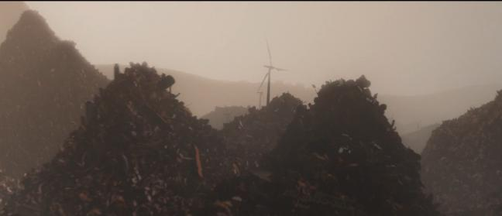

Fig. 2 <WALL.E>Background modeling of the starting

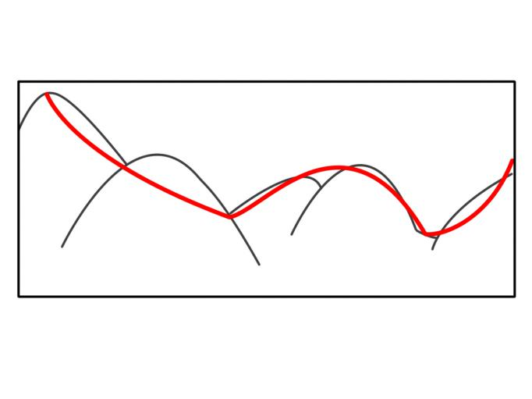

Fig. 3 <WALL.E>Application of continuity principle diagram

Fig. 2 is a scene model that appears at the beginning of <WALL.E>, where the designer depicts a world full of junk through background modeling, but when people look at these background modelings which do not create a clutter in the human visual. Because there are a lot of rubbish in the picture, they all appear in a similar triangle shape, and as can be seen from the explanatory diagram of Fig. 3, the arrangement of these rubbish heaps follows the principle of continuity, that is, visually form a clear direction of the ups and downs. It is precisely because of this arrangement of designers, in order to allow messy rubbish heap in the visual form of a regular manner, the formation of a systematic form of space.

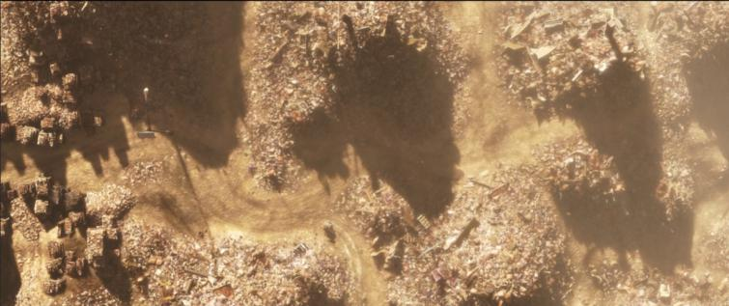

Fig. 4 <WALL.E> Background Modeling of the Starting

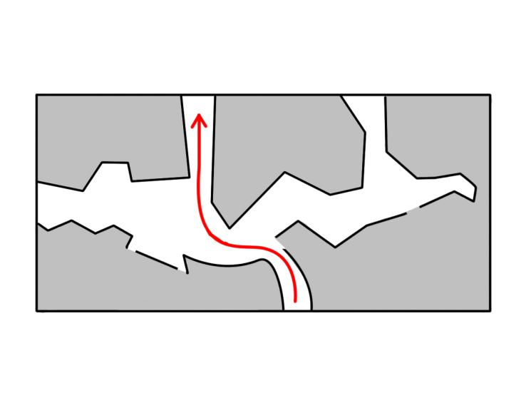

Fig. 5 <WALL.E> Application of Continuity Principle Diagram

Fig. 4 is another scene at the beginning of <WALL.E>, which is a top-down view of the scene. It showed the audience that the protagonist robot is shuttling in the garbage scene. There is no strict connection between the rubbish heaps, but they are visually integrated and form an airtight space, which also has a clear directionality. By arranging the rubbish heap intelligently, using the principle of closure and continuity, designers perceive the audience as having a path in the rubbish heap, which is the embodiment of form systematization. The protagonist is through this path, the shuttle in the garbage.



Fig. 6 <Despicable me> Red castle background modeling

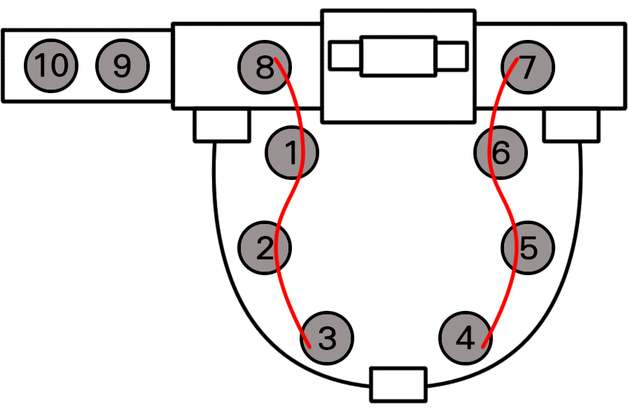

Fig. 7 Top view of the red castle

This is the background modeling that appears at the end of the climax in <Despicable me>. Through the principle of proximity, the designers make the Fig. 10 circular small background modeling presented systematic morphology of 1,2,3,8 a group, 4,5,6,7 a group, 9 and 10 a group. At the same time 1,2,3,8 and 4,5,6,7 these two groups is still symmetrical morphology. All background modeling is based on the red color, that is, the color is similar in order to form a systematic visual form. And the shapes of the 10-circular small background modeling are also similar. Therefore, designers through the principle of proximity, the principle of color similarity, the principle of shape similarity, so that background modeling presents a regular, single, symmetrical system of the form.
Through the principle of continuity, adjust the level between the garbage dumps, and make it arranged in a certain direction, forming coherent ups and downs, thus avoid the clutter of visual experience. Through the principle of closure and continuity, place the garbage dumps dexterously, form a visual, airtight, directional "path" shape. Through the principle of proximity, 10 prototypes of background modeling are visually arranged into several symmetrical groups to form a systematic arrangement. Through the similar color, background modeling unified to design red. As you can see from the above example, designers do intend to use background principles to design background modeling into a systematic, single, symmetrical pattern. This fact can provide some support for the appropriateness of this standard. Although it is not possible to fully confirm whether they were designing on the basis of the Gestalt principle of organization, it can be seen from the just case analysis that it is feasible to use the principle of organization to achieve systematic visualization, at least for confirmation Yes, the organizing principle is an appropriate way to implement the form systematization, and this form systematization has also been applied in 3D animation.

IV. Conclusion

In order to study how to achieve the form systematization, control the arrangement of background modeling, grasp the spatiality of background modeling and improve the visual effects of 3D animation. Therefore, the paper first proposed in advance a hypothetical standard: the background modeling in the space of the law, symmetry, a single arrangement can produce systematic visual and conscious experience, achieve form systematization. Secondly, we investigate the Gestalt principle of organization characteristics, which focus on visual perception. The relationship between these principles and the standard is revealed. The principle of proximity classifies elements according to the distance between elements. The similarity principle is based on the element size, shape, color, material and other properties of the different elements of the classification; the principle of continuity according to the direction of the elements arranged in the direction of the strength of the elements classified; closed principle will be gapped, insecure elements as possible into a complete, single form. The four principles realize form systematization by means of categorization, so the organizing principle is the means to achieve form systematization. Then, taking the 3D animated works "WALL.E" and "Despicable me" of well-known animation companies Disney, Pixar and Universal Studios as an example, this paper analyzes the application of the form systematization standard in the animation and adjusts the garbage collection by the principle of continuity between the level and make it arranged in a certain direction, forming a coherent ups and downs, thus avoiding the clutter of visual experience. Through the principle of closure and continuity, clever placement of garbage dumps, the formation of a visual, airtight, directional "path" shape. Through the principle of proximity, 10 circular background models are visually arranged into several symmetrical groups for systematic arrangement. Similar to the color, background modeling will be unified into a red, forming a unified whole. The organizing principle is an appropriate way to implement the form systematization, and this form systematization has also been applied in 3D animation. The use of standards, rational arrangement of the background modeling, to achieve form systematization, can produce regular, comfortable, overall, simple visual experience.

References

- H. Cho, M. Moon, “A study on expressing the spatiality by windows and walls,” M.S. Division of Arts and Craft, The Graduate School of Ewha Woman's University, Seoul，Korea, 2003.
- J. Shin, “A study on media-facade applying the visual perception theory of Gestalt,” Korea Digital Design Council, vol.12, no.3, pp. 301-310, July 2012.
[3] A. Rudolf, Art and visual perception, Seoul: Ewha Women University, pp. 47-93, 2003.
[4] N. Tsusumi, The idea of the form-for the research on the forms, Seoul: Changmi Press, pp. 27-34, 1994.
[5] K. Kurt, The Principle of Gestalt Psychology, Beijing: Peking University Press, pp. 29-54, 2010.
[6] Y. Lee, H. Kim, “A Study on Expression of Motion Graphic with Gestalt theory,” Korea Digital Design Society, vol. 11, no.1, pp. 243-253, January 2011.
[7] J. Shin, “A study on media-facade applying the visual perception theory of Gestalt,” Korea Digital Design Council, vol.12, no.3, pp. 301-310, July 2012.
[8] K. Kim, Y. Yun, “Formative Properties of 3D Animation based on the Theory of Gestalt,” The Korea Contents Society, vol. 4, no.1, pp. 279-284, May 2006.
[9] J. Park, H. Kwon and H. Kim, “A Study of Digital Video Production based on the Gestalt Visual Perception Theory,” Korea Digital Design Council, vol. 10, no.2, pp. 117-126, April 2010.
[10] H. Ko, “A research on the expressions of the web designs utilizing the formative principle of Gestalt,” M.S. thesis, Department of Design Education, Kyunghee University, Seoul，Korea, 2003.
[11] Y. Lee, H. Kim, “A Study on Expression of Motion Graphic with Gestalt theory,” Journal of Digital Design, vol. 11, no. 1, pp. 243-253, January 2011.
[12] L. Gu, H. Jeon and H. Pak, “A study on the formal systematization within the 3D modeling designs,” Journal of Multimedia and Information Systems, vol. 4, no. 3, pp. 107-114, September 2017.

